Blockchain Model for Bus Reservation System
SHEIKHA ABDULLAH SULAIMAN SUBAIYA AL HASANI 36J2168
ZUMURUD HAMED AL SHABIBI 36S2023

This case study explores the use of blockchain model for a Bus Reservation System using Hyperledger Fabric. This model will allow for transparent, secure, and immutable transactions related to bus reservations, including adding buses, making bookings, modifying passenger details, and managing seat availability.

The core entities involved in the Bus Reservation System will include:
Bus: Contains information about buses, such as bus ID, company, source, destination, etc.
Passenger: Details of the passenger, such as ID, name, email, and phone number.
Booking: Details of the booking made by the passenger, such as booking ID, passenger ID, bus ID, and booking status.

You are expected to do the following:
- Write a model file for the given scenario.
- Include the following transaction to add, modify and to update the Passenger details

- Grant business network administrators’ full access to system resources
- Grant business network administrators’ full access to user resources
- Allow participants to access the system
- Deploy and test the business network
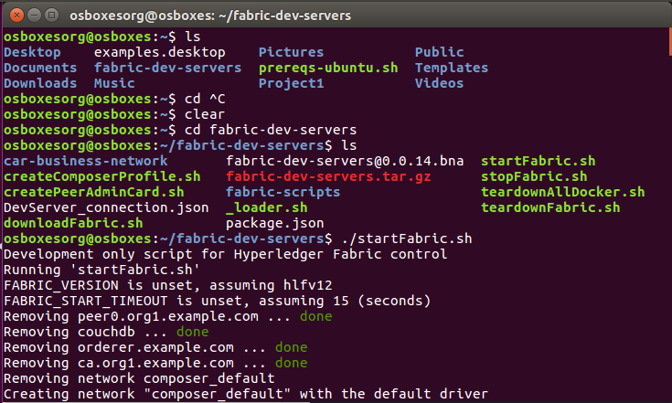
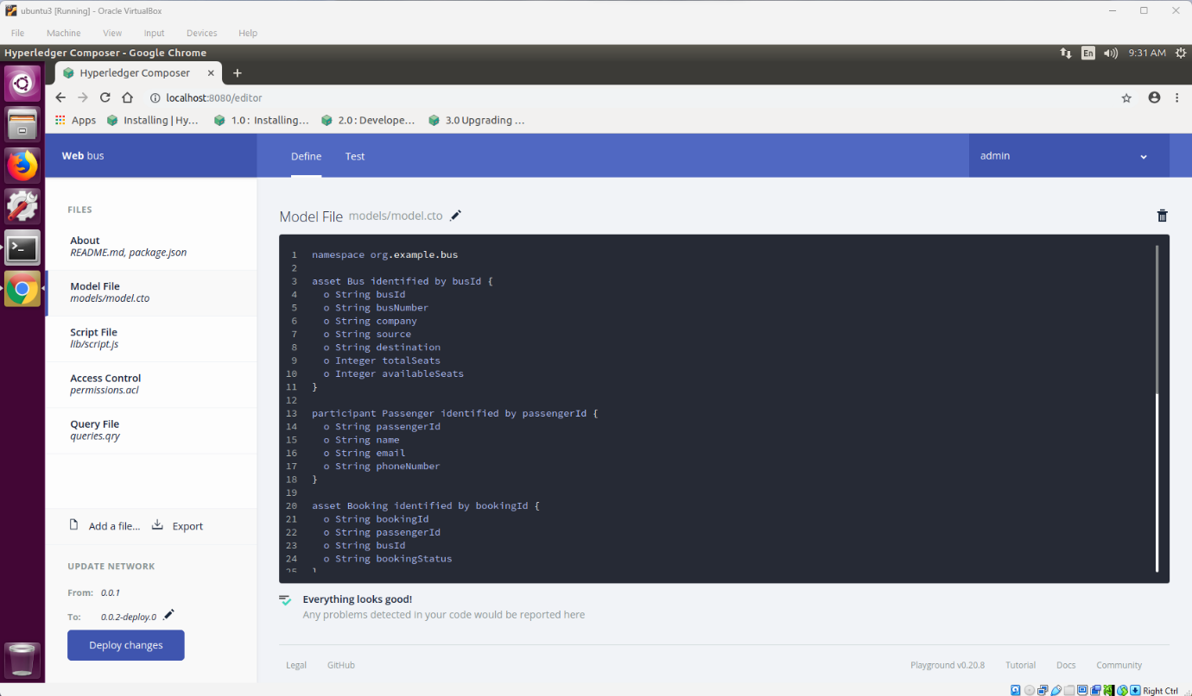
model file:
namespace org.example.bus

asset Bus identified by busId {
o String busId
o String busNumber
o String company
o String source
o String destination
}

participant Passenger identified by passengerId {
o String passengerId
o String name
o String email
o String phoneNumber
}

asset Booking identified by bookingId {
o String bookingId
--> Passenger passenger
--> Bus bus
o String bookingStatus
}

transaction AddPassenger {
o String passengerId
o String name
o String email
o String phoneNumber
}

transaction ModifyPassenger {
--> Passenger passenger
o String name
o String email
o String phoneNumber
}
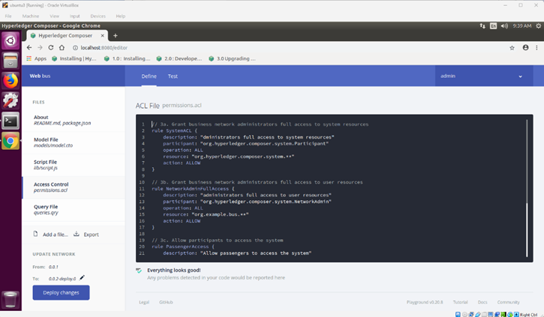
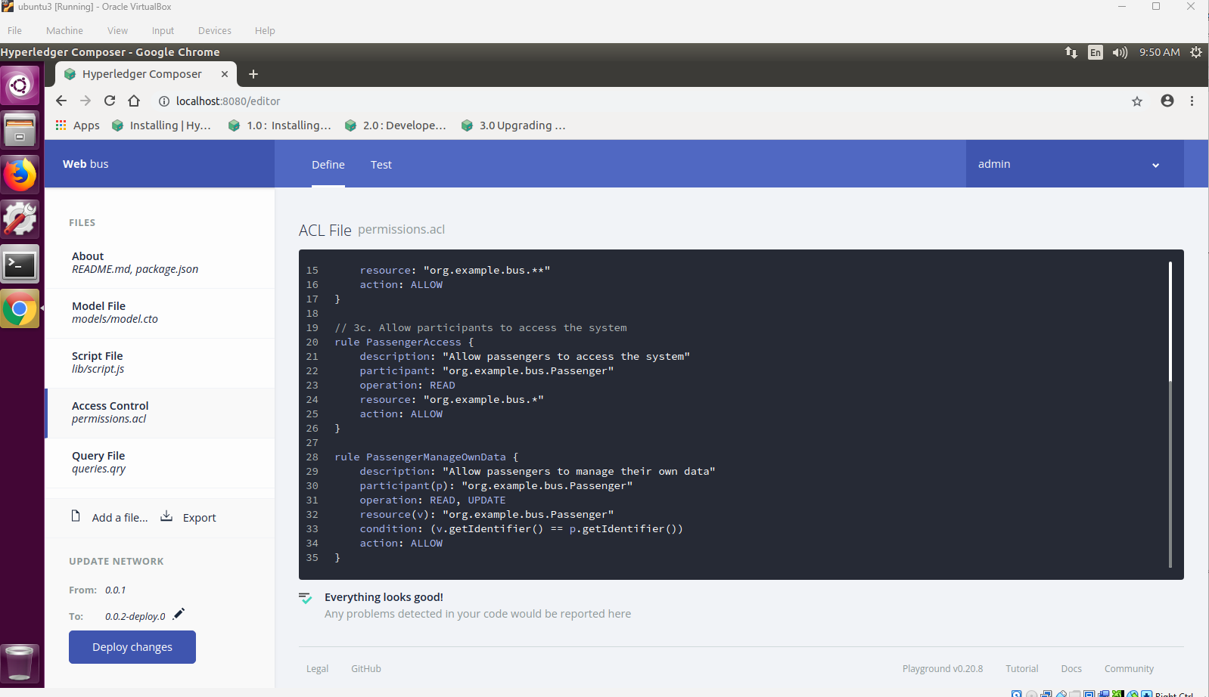
Access control file:
rule SystemACL {
description: "System administrators can do everything"
participant: "org.hyperledger.composer.system.NetworkAdmin"
operation: ALL
resource: "org.hyperledger.composer.system.**"
action: ALLOW
}

rule NetworkAdminFullAccess {
description: "Network administrators full access"
participant: "org.hyperledger.composer.system.NetworkAdmin"
operation: ALL
resource: "org.example.bus.*"
action: ALLOW
}

rule PassengerAccess {
description: "Passengers can read all"
participant: "org.example.bus.Passenger"
operation: READ
resource: "org.example.bus.*"
action: ALLOW
}

rule PassengerManageOwnData {
description: "Passengers can manage own data"
participant(p): "org.example.bus.Passenger"
operation: READ, UPDATE
resource(v): "org.example.bus.Passenger"
condition: (v.getIdentifier() == p.getIdentifier())
action: ALLOW
}
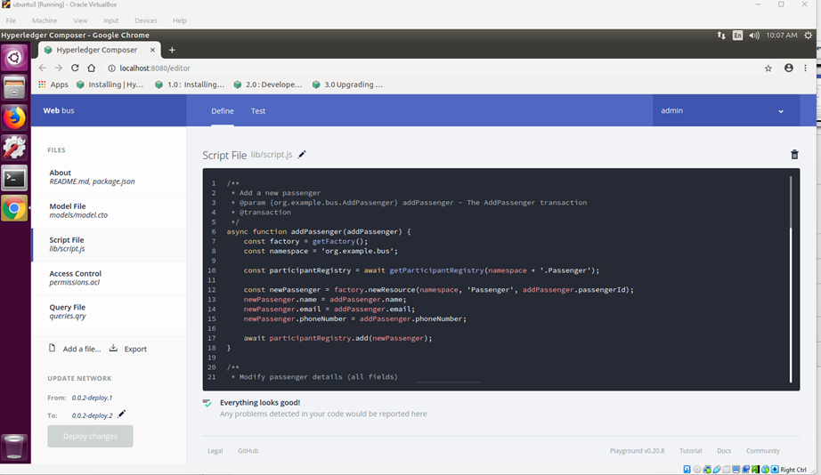
Script file:
/**
* Add a new passenger
* @param {org.example.bus.AddPassenger} addPassenger - the transaction
* @transaction
*/
async function addPassenger(addPassenger) {
const factory = getFactory();

const parRegistry = await getParticipantRegistry('org.example.bus.Passenger');

const newPassenger = factory.newResource('org.example.bus','Passenger', addPassenger.passengerId);
newPassenger.name = addPassenger.name;
newPassenger.email = addPassenger.email;
newPassenger.phoneNumber = addPassenger.phoneNumber;

await parRegistry.add(newPassenger);
}

/**
* Modify passenger details
* @param {org.example.bus.ModifyPassenger} modifyPassenger - the transaction
* @transaction
*/
async function modifyPassenger(modifyPassenger) {
const parRegistry = await getParticipantRegistry('org.example.bus.Passenger');

const passenger = await parRegistry.get(modifyPassenger.passengerId);
passenger.name = modifyPassenger.name;
passenger.email = modifyPassenger.email;
passenger.phoneNumber = modifyPassenger.phoneNumber;

await parRegistry.update(passenger);
}
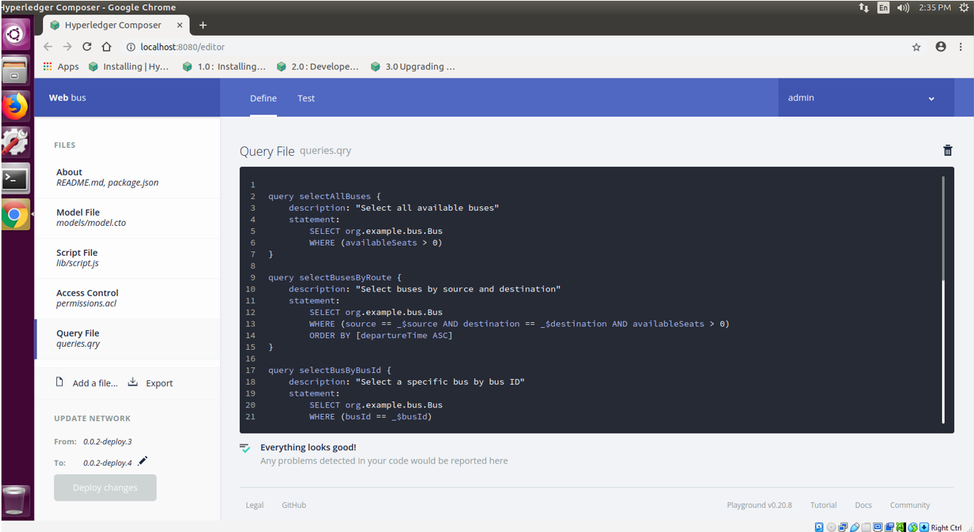
Query file:
query selectAllBuses {
description: "Select all available buses"
statement:
SELECT org.example.bus.Bus
ORDER BY [busId ASC]
}

query selectBusesByRoute {
description: "Select buses by source and destination"
statement:
SELECT org.example.bus.Bus
WHERE (source == _$source AND destination == _$destination )
ORDER BY [departureTime ASC]
}

query selectBusByBusId {
description: "Select a specific bus by bus ID"
statement:
SELECT org.example.bus.Bus
WHERE (busId == _$busId)
}

query selectPassengerBookings {
description: "Select all bookings for a specific passenger"
statement:
SELECT org.example.bus.Booking
WHERE (passenger.passengerId ==_$passengerId)
ORDER BY [bookingDate DESC]
}

query selectBookingsByStatus {
description: "Select bookings by status"
statement:
SELECT org.example.bus.Booking
WHERE (bookingStatus == _$status)
}

query selectAvailableBusesByType {
description: "Select available buses by bus type"
statement:
SELECT org.example.bus.Bus
WHERE (company == _$company )
}

query selectPassengerByEmail {
description: "Select passenger by email"
statement:
SELECT org.example.bus.Passenger
WHERE (email == _$email)
}
Create BNA:
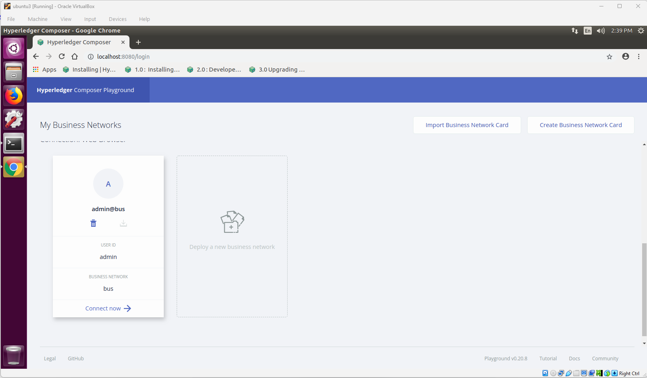
Add Passenger Transaction:
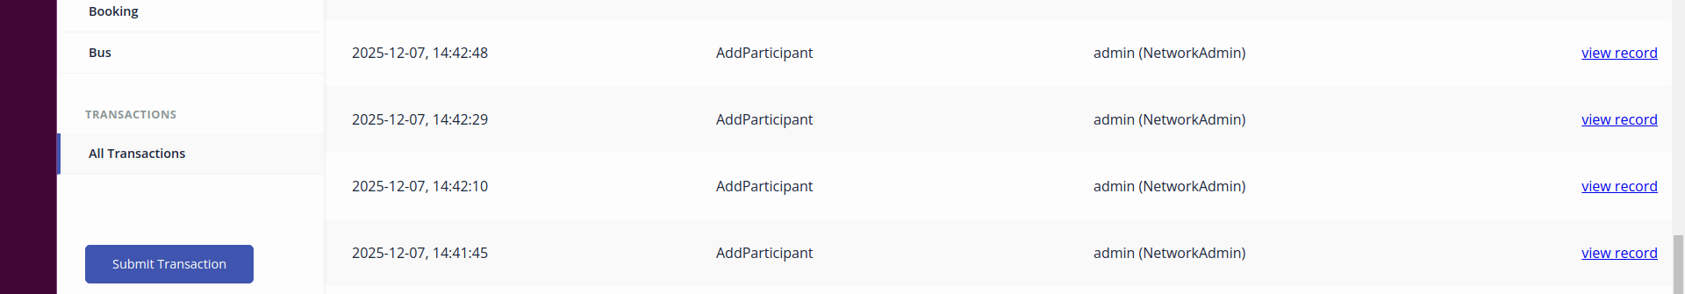
Update Passenger:
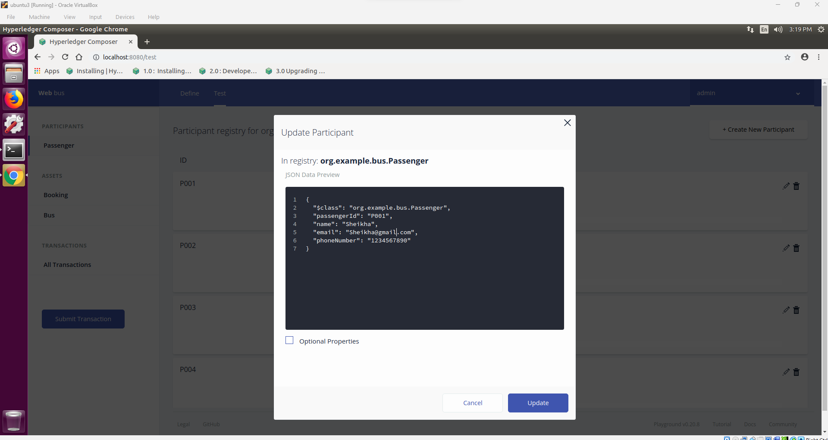
Verify Updated Passenger:
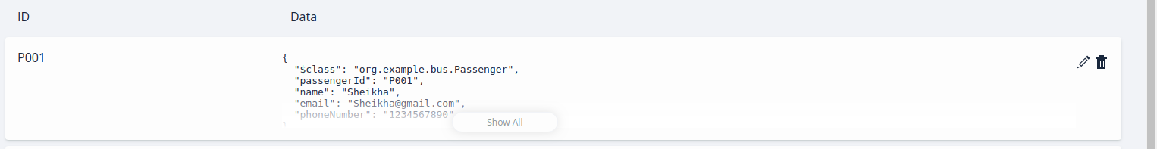
Create Passenger Identity:
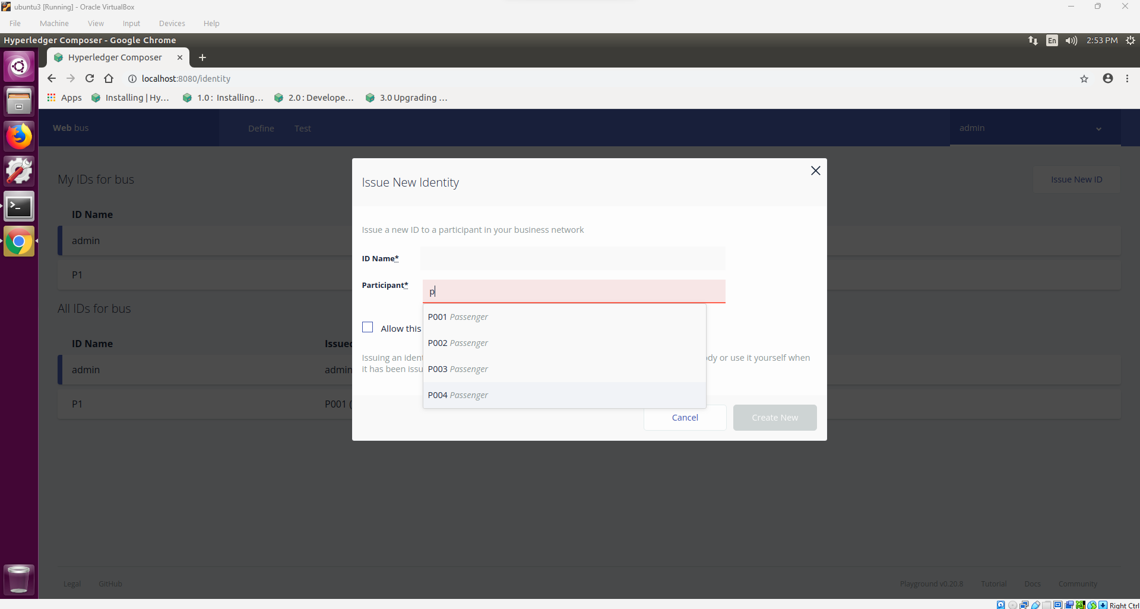
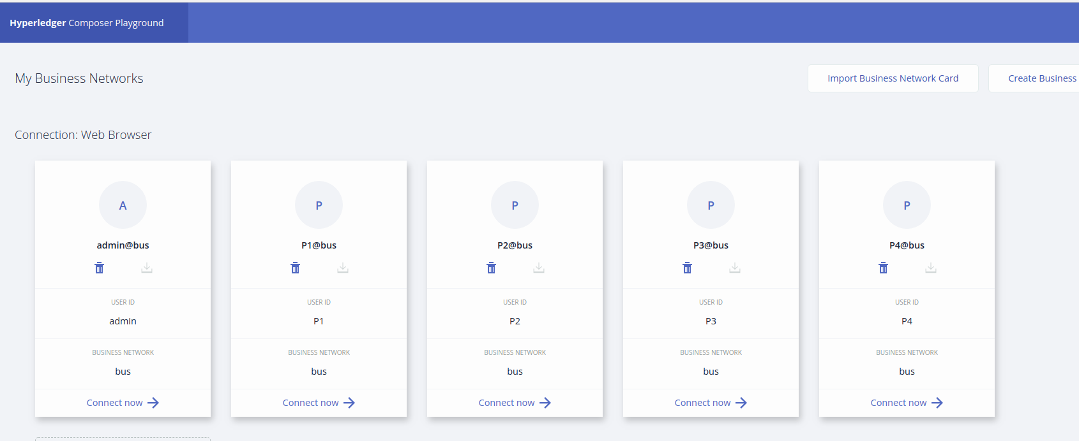
Test the Passenger Access:
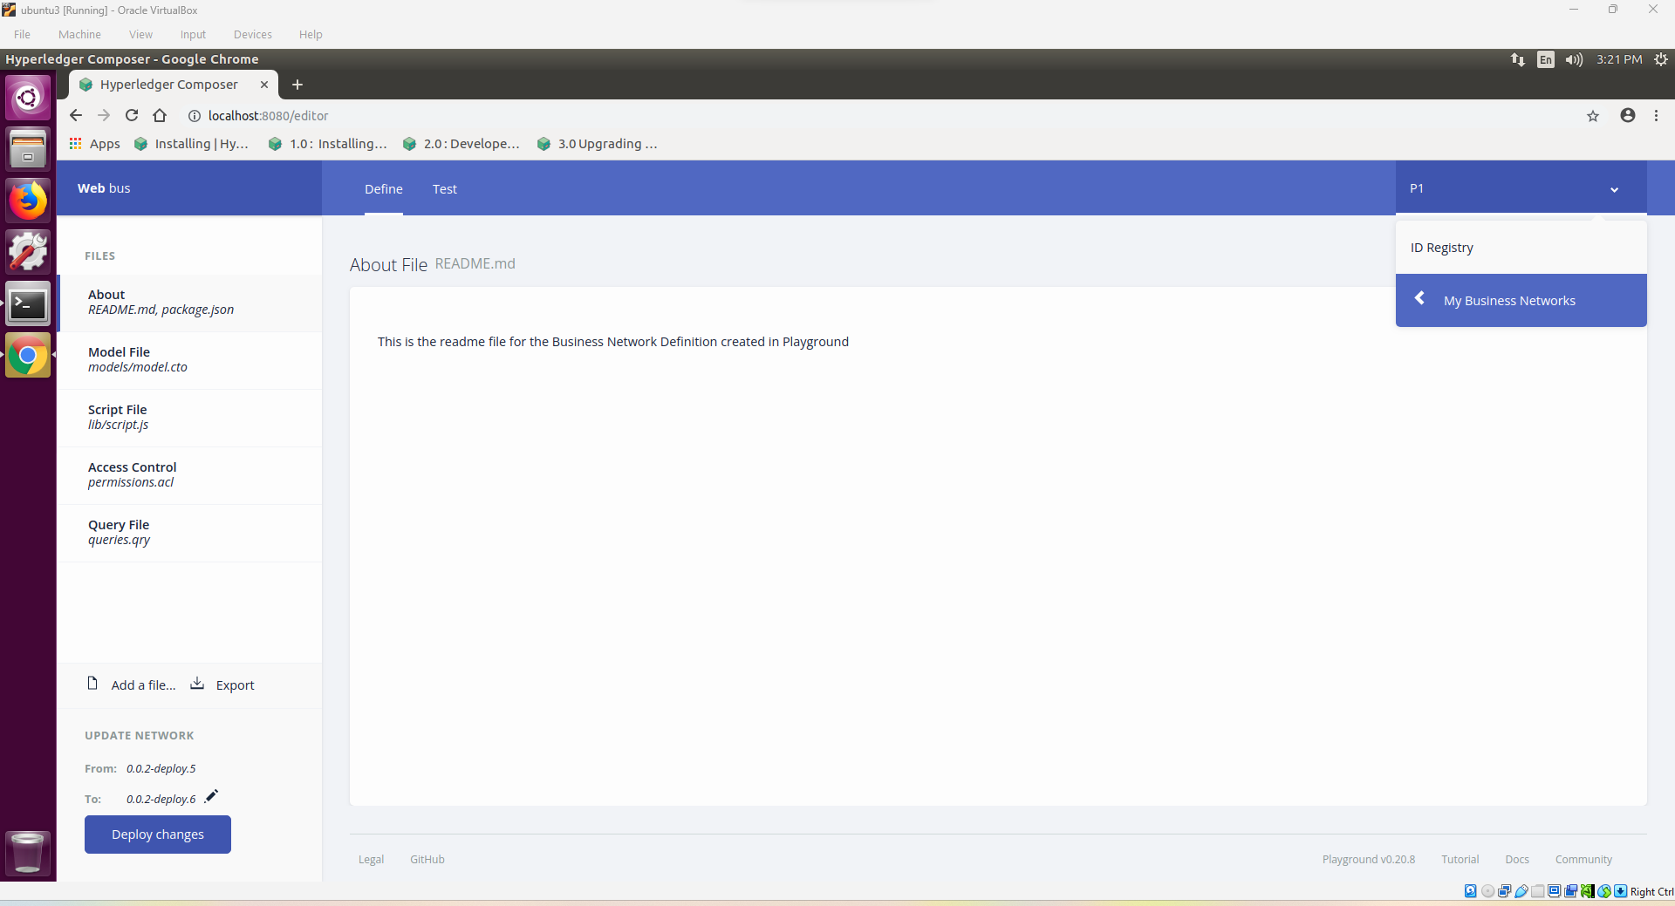
All Participants:
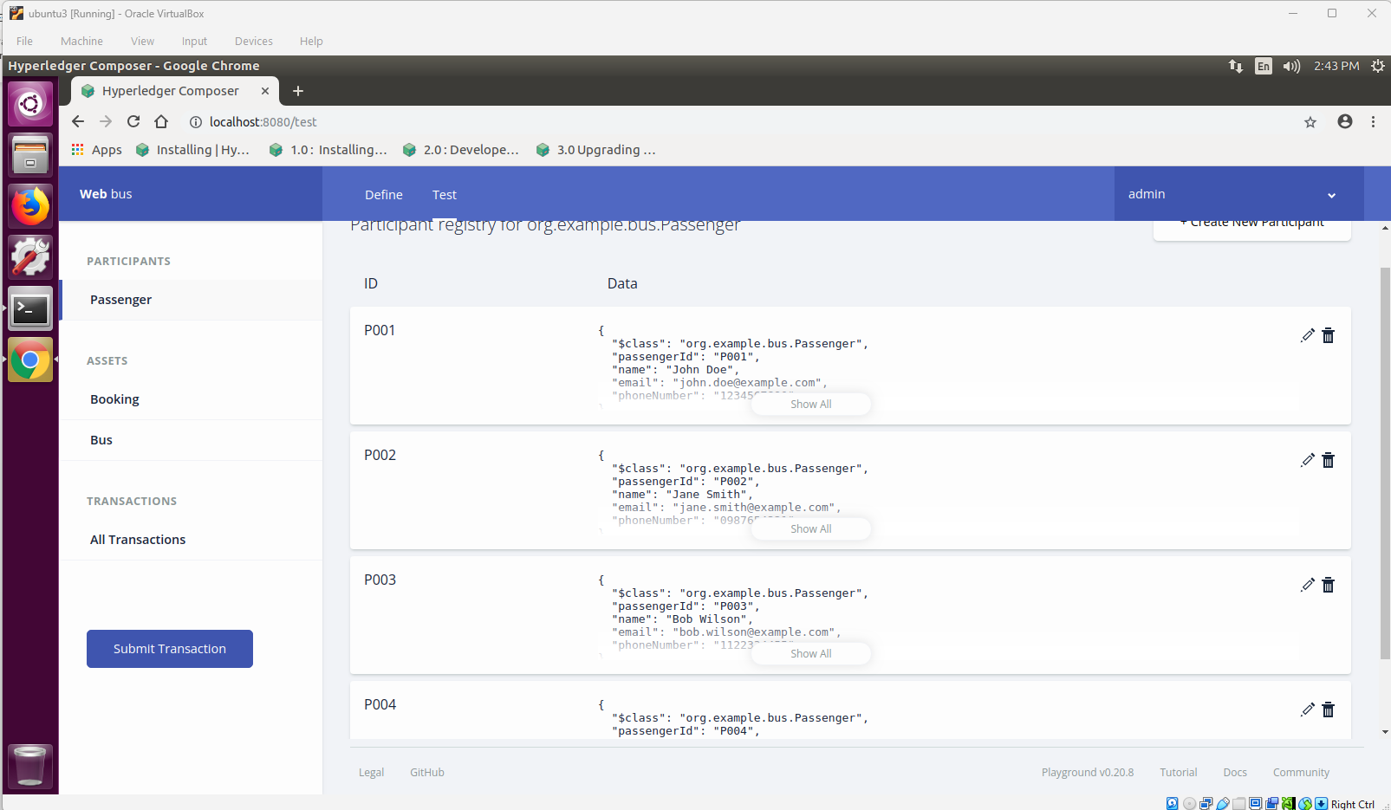
All Assets:
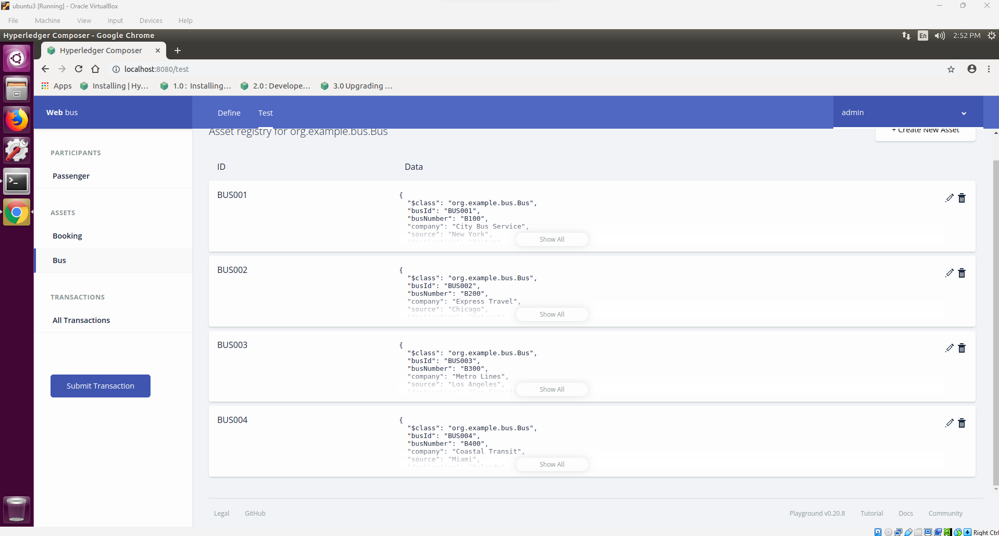
Transaction History:
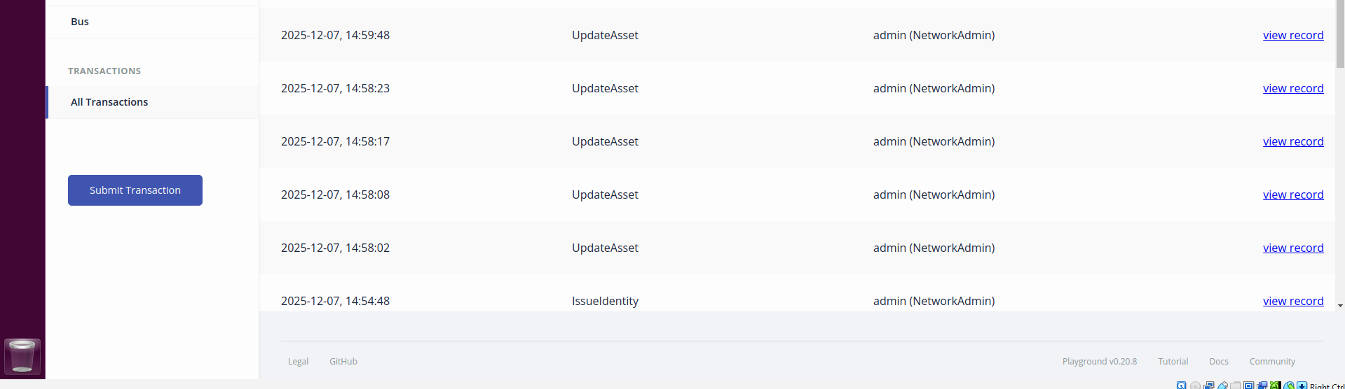
System Overview:


